Load Test Report

## Load Details

Stack: S1

Stack Url: https://jupiter.uptycs.net/

Sprint: 139

Build: 138005

Load Name: MultiCustomer

Load Duration In Hrs: 10 hrs

Load Start Time Ist: 2023-09-04 00:33

Load End Time Ist: 2023-09-04 10:33

Customers: 120

Number Of Customers With Auto Exception Enabled: 0

Test Type: Rule Engine Load and Control Plane Load

Customer: Multiple

Total Assets: 80K Control Plane +15K Multi customer

Records Sent Per Hour Per Customer: 8164800

Records Sent Per Hour: 979776000 (979 million)

Input File: rhel7-6tab_12rec.log

Events Table Name: dns_lookup_events, socket_events, process_events, process_file_events

### Test Environment details

|  |  |  |  |  |
| --- | --- | --- | --- | --- |
| node | cluster | cores | ram | storage |
| s1c1pn1 | 1 | 32 | 188 | root_partition:365G, kafka:3.6T, |
| s1c1pn2 | 1 | 32 | 188 | root_partition:365G, kafka:3.6T, |
| s1c1pn3 | 1 | 32 | 188 | root_partition:365G, kafka:3.6T, |
| s1c1pn4 | 1 | 32 | 188 | root_partition:365G, kafka:3.6T, |
| s1c1pn5 | 1 | 32 | 188 | root_partition:365G, kafka:3.6T, |
| s1c1pn6 | 1 | 32 | 188 | root_partition:365G, kafka:3.6T, |
| s1c2pn1 | 2 | 32 | 188 | root_partition:365G, kafka:3.6T, |
| s1c2pn2 | 2 | 32 | 188 | root_partition:365G, kafka:3.6T, |
| s1c2pn3 | 2 | 32 | 188 | root_partition:365G, kafka:3.6T, |
| s1c2pn4 | 2 | 32 | 188 | root_partition:365G, kafka:3.6T, |
| s1c2pn5 | 2 | 32 | 188 | root_partition:365G, kafka:3.6T, |
| s1c2pn6 | 2 | 32 | 188 | root_partition:365G, kafka:3.6T, |
| s1c1dn1 | 1 | 32 | 251 | root_partition:365G, spark:3.6T, dn1:3.6T, dn2:3.6T, dn3:3.6T, |
| s1c1dn2 | 1 | 32 | 251 | root_partition:365G, spark:3.6T, dn1:3.6T, dn2:3.6T, dn3:3.6T, |
| s1c1dn3 | 1 | 32 | 251 | root_partition:365G, spark:3.6T, dn1:3.6T, dn2:3.6T, dn3:3.6T, |
| s1c1dn4 | 1 | 32 | 188 | root_partition:365G, spark:3.6T, dn1:3.6T, dn2:3.6T, dn3:3.6T, |
| s1c1dn5 | 1 | 32 | 188 | root_partition:365G, spark:3.6T, dn1:3.6T, dn2:3.6T, dn3:3.6T, |
| s1c1dn6 | 1 | 32 | 188 | root_partition:365G, spark:3.6T, dn1:3.6T, dn2:3.6T, dn3:3.6T, |
| s1c2dn1 | 2 | 32 | 251 | root_partition:365G, spark:3.6T, dn1:3.6T, dn2:3.6T, dn3:3.6T, |
| s1c2dn2 | 2 | 32 | 251 | root_partition:365G, spark:3.6T, dn1:3.6T, dn2:3.6T, dn3:3.6T, |
| s1c2dn3 | 2 | 32 | 251 | root_partition:365G, spark:3.6T, dn1:3.6T, dn2:3.6T, dn3:3.6T, |
| s1c2dn4 | 2 | 32 | 188 | root_partition:365G, spark:3.6T, dn1:3.6T, dn2:3.6T, dn3:3.6T, |
| s1c2dn5 | 2 | 32 | 188 | root_partition:365G, spark:3.6T, dn1:3.6T, dn2:3.6T, dn3:3.6T, |
| s1c2dn6 | 2 | 32 | 188 | root_partition:365G, spark:3.6T, dn1:3.6T, dn2:3.6T, dn3:3.6T, |
| s1configdb1 | 1 | 32 | 188 | root_partition:365G, pg:3.5T, data:3.5T, |
| s1configdb2 | 1 | 32 | 188 | root_partition:365G, pg:5.5T, data:5.5T, |
| s1monitor | 1 | 16 | 62 | root_partition:98G, data_prometheus:3.6T, |

## Disk Usages

### KAFKA disk space usage

|  |  |  |  |  |
| --- | --- | --- | --- | --- |
| Node | KAFKA total space configured(TB) | KAFKA disk used % before load | KAFKA disk used % after load | KAFKA used space during load (GB) |
| s1c1pn1 | 3.6 | 4.0 | 4.0 | 0.0 |
| s1c1pn2 | 3.6 | 5.0 | 5.0 | 0.0 |
| s1c1pn3 | 3.6 | 4.0 | 4.0 | 0.0 |
| s1c1pn4 | 3.6 | 5.0 | 5.0 | 0.0 |
| s1c1pn5 | 3.6 | 5.0 | 5.0 | 0.0 |
| s1c1pn6 | 3.6 | 4.0 | 4.0 | 0.0 |
| s1c2pn1 | 3.6 | 5.0 | 5.0 | 0.0 |
| s1c2pn2 | 3.6 | 4.0 | 4.0 | 0.0 |
| s1c2pn3 | 3.6 | 4.0 | 4.0 | 0.0 |
| s1c2pn4 | 3.6 | 4.0 | 4.0 | 0.0 |
| s1c2pn5 | 3.6 | 5.0 | 5.0 | 0.0 |
| s1c2pn6 | 3.6 | 5.0 | 5.0 | 0.0 |

### HDFS disk space usage

|  |  |  |  |  |
| --- | --- | --- | --- | --- |
| Node | HDFS total space configured(TB) | HDFS disk used % before load | HDFS disk used % after load | HDFS used space during load (GB) |
| s1c1dn3 | 11.78 | 6.27 | 6.28 | 2.28 |
| s1c1dn6 | 11.78 | 6.25 | 6.27 | 2.28 |
| s1c2dn2 | 11.78 | 6.25 | 6.28 | 3.06 |
| s1c2dn4 | 11.78 | 6.23 | 6.26 | 3.04 |
| s1c1dn4 | 11.78 | 6.23 | 6.26 | 3.16 |
| s1c2dn6 | 11.78 | 6.22 | 6.24 | 2.11 |
| s1c1dn1 | 11.78 | 6.22 | 6.23 | 1.78 |
| s1c2dn1 | 11.78 | 6.21 | 6.22 | 1.55 |
| s1c1dn2 | 11.78 | 6.17 | 6.19 | 2.85 |

### PG disk space usage

|  |  |  |
| --- | --- | --- |
| partition | master configdb node | standby configdb node |
| /pg | 7.2G | 4.4G |
| /data | 29G | 28G |

### Kafka topics

|  |
| --- |
| 138005 |
| Summary : New topics found |
| New Topics : __consumer_offsets __debezium-heartbeat.cdc __debezium-heartbeat.statedb agentghquery agentkubequery agentlesslog agentlesslogdecorator agentoktaquery agentosquery alert alert_replay api asset-capability assetgroup1 audit auto-exception az_events_blob bulk_replay cdc.public.alerts cdc.public.asset_cloud_infos cdc.public.asset_tags cdc.public.assets cdc.public.cloud_accounts cdc.public.customer_database cdc.public.customers cdc.public.incidents cdc.public.object_groups cdc.public.user_object_groups cdc.public.users cloudconnectorsink cloudqueryVuln cloudqueryevents cloudqueryinventory cloudtrail_objects compliance compliance_summary containers cqazevents cqcloudtrail cqcloudtrail_data_sink cqcloudtrail_ro_sink debezium_configs debezium_offsets debezium_statedb_configs debezium_statedb_offsets debezium_statedb_status_storage debezium_status_storage decorators detection ephermalresources epsink event event_cloud event_replay gcp_cloudlog_objects managedavtables notifications op osquery_cli_tags prestoquerylogs querypack realtimequery registryevent reportschedule1 scan_summary sidequerydecorator slackuser1 state statedb.public.containers_current statedb.public.kubernetes_nodes_current statedb.public.kubernetes_pods_containers_current statedb.public.kubernetes_pods_current statedb.public.vulnerabilities_scanned_images tag1 threat_indicators unified_dashboard uptycs-cloud-remediation vulnerabilities vulntickets |
| Old Topics : |

## Charts

### Live assets

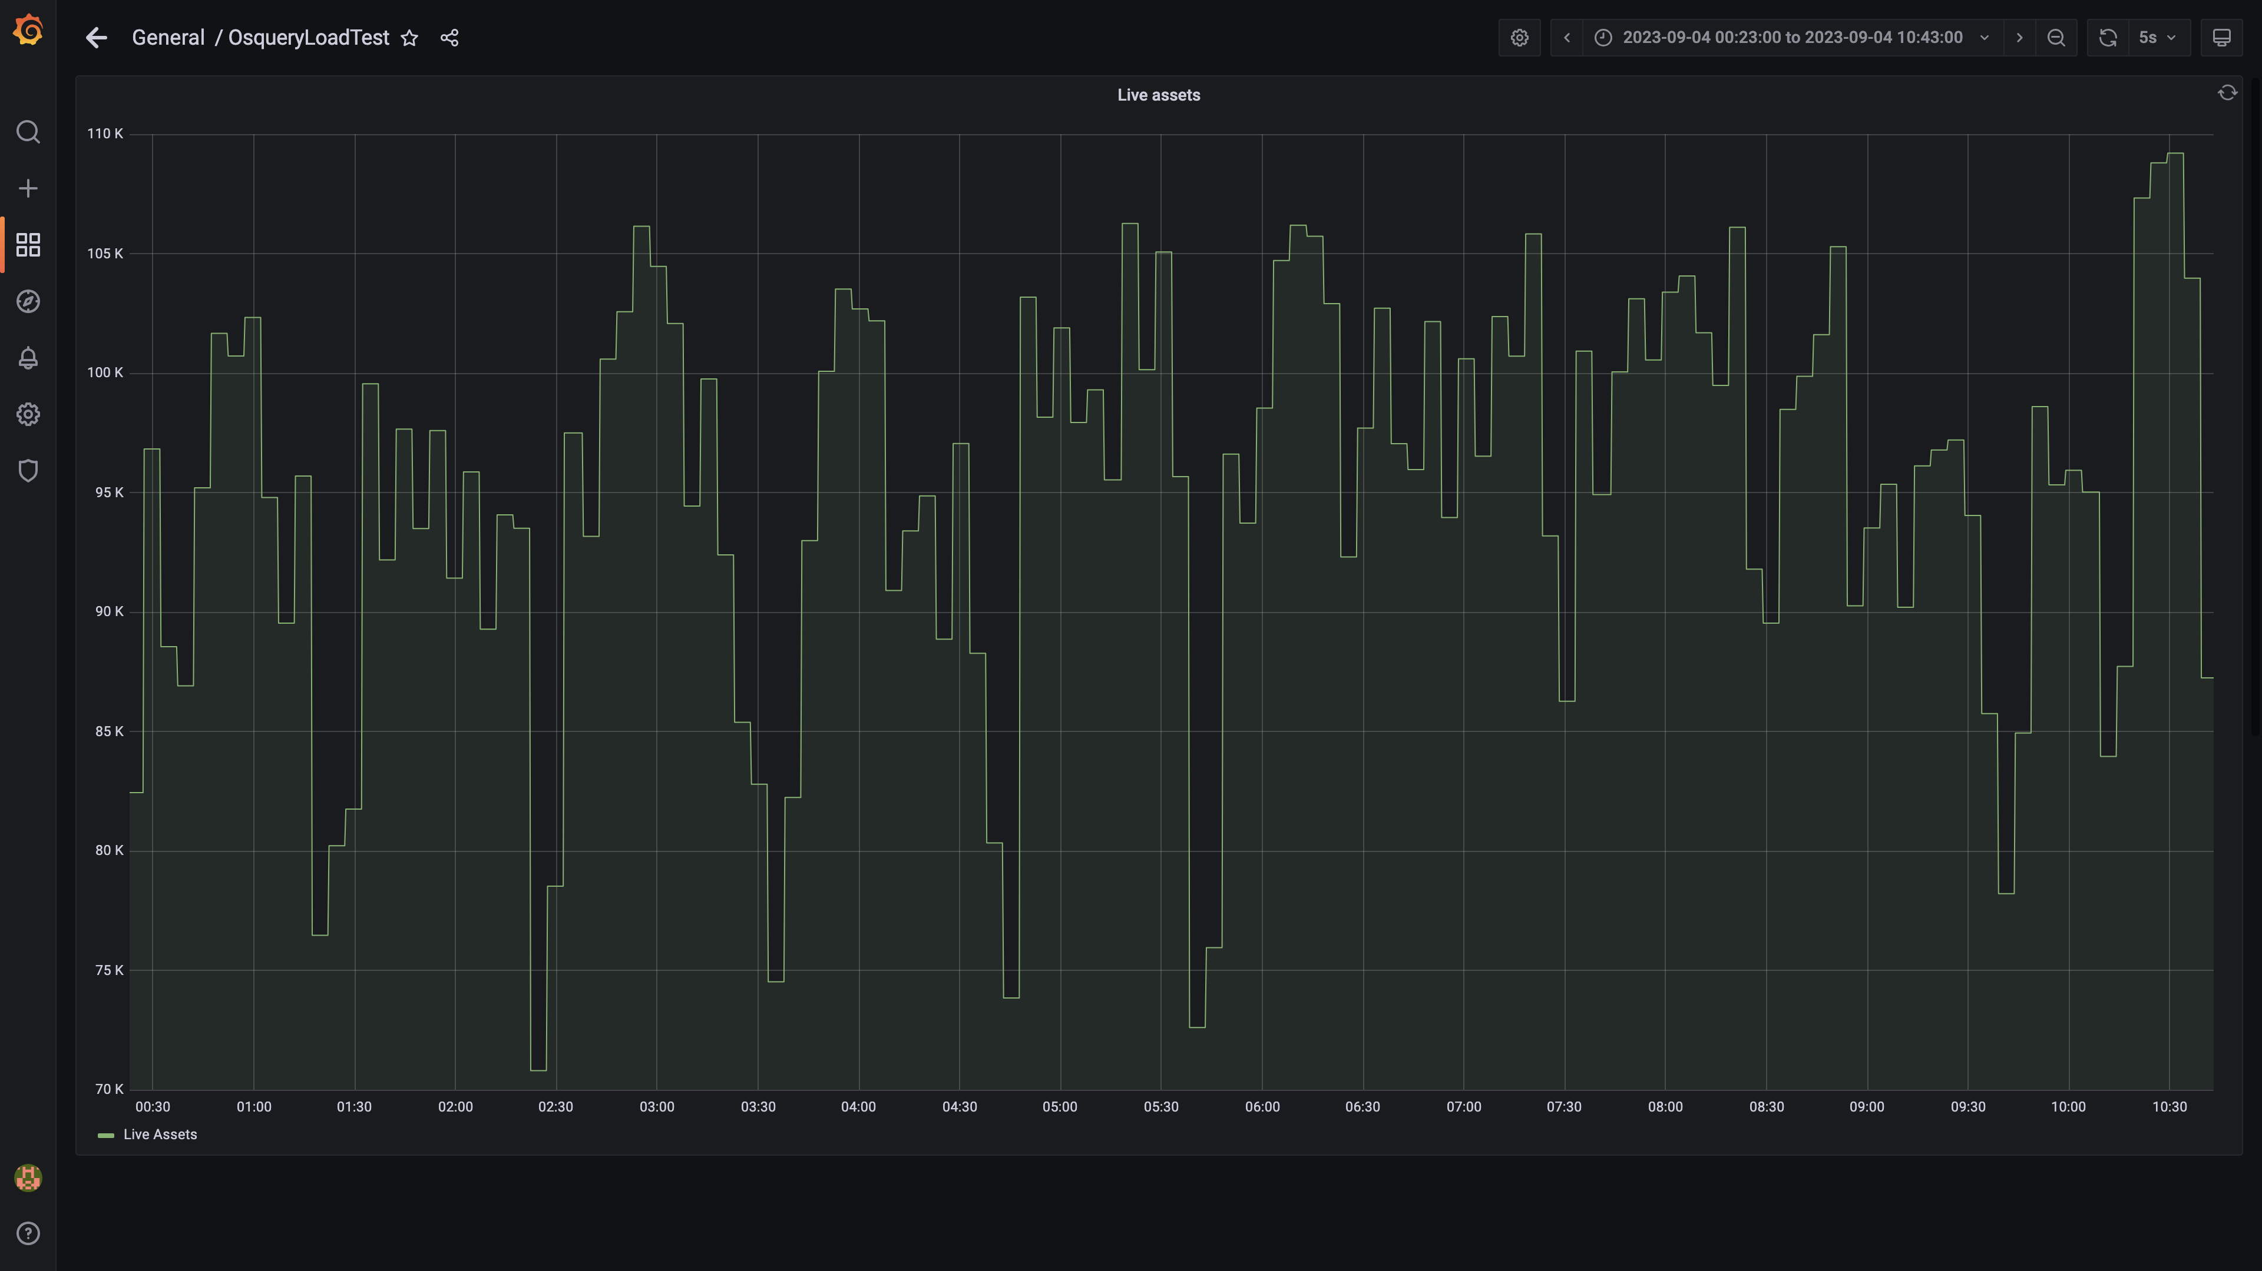

### Kafka lag for all groups

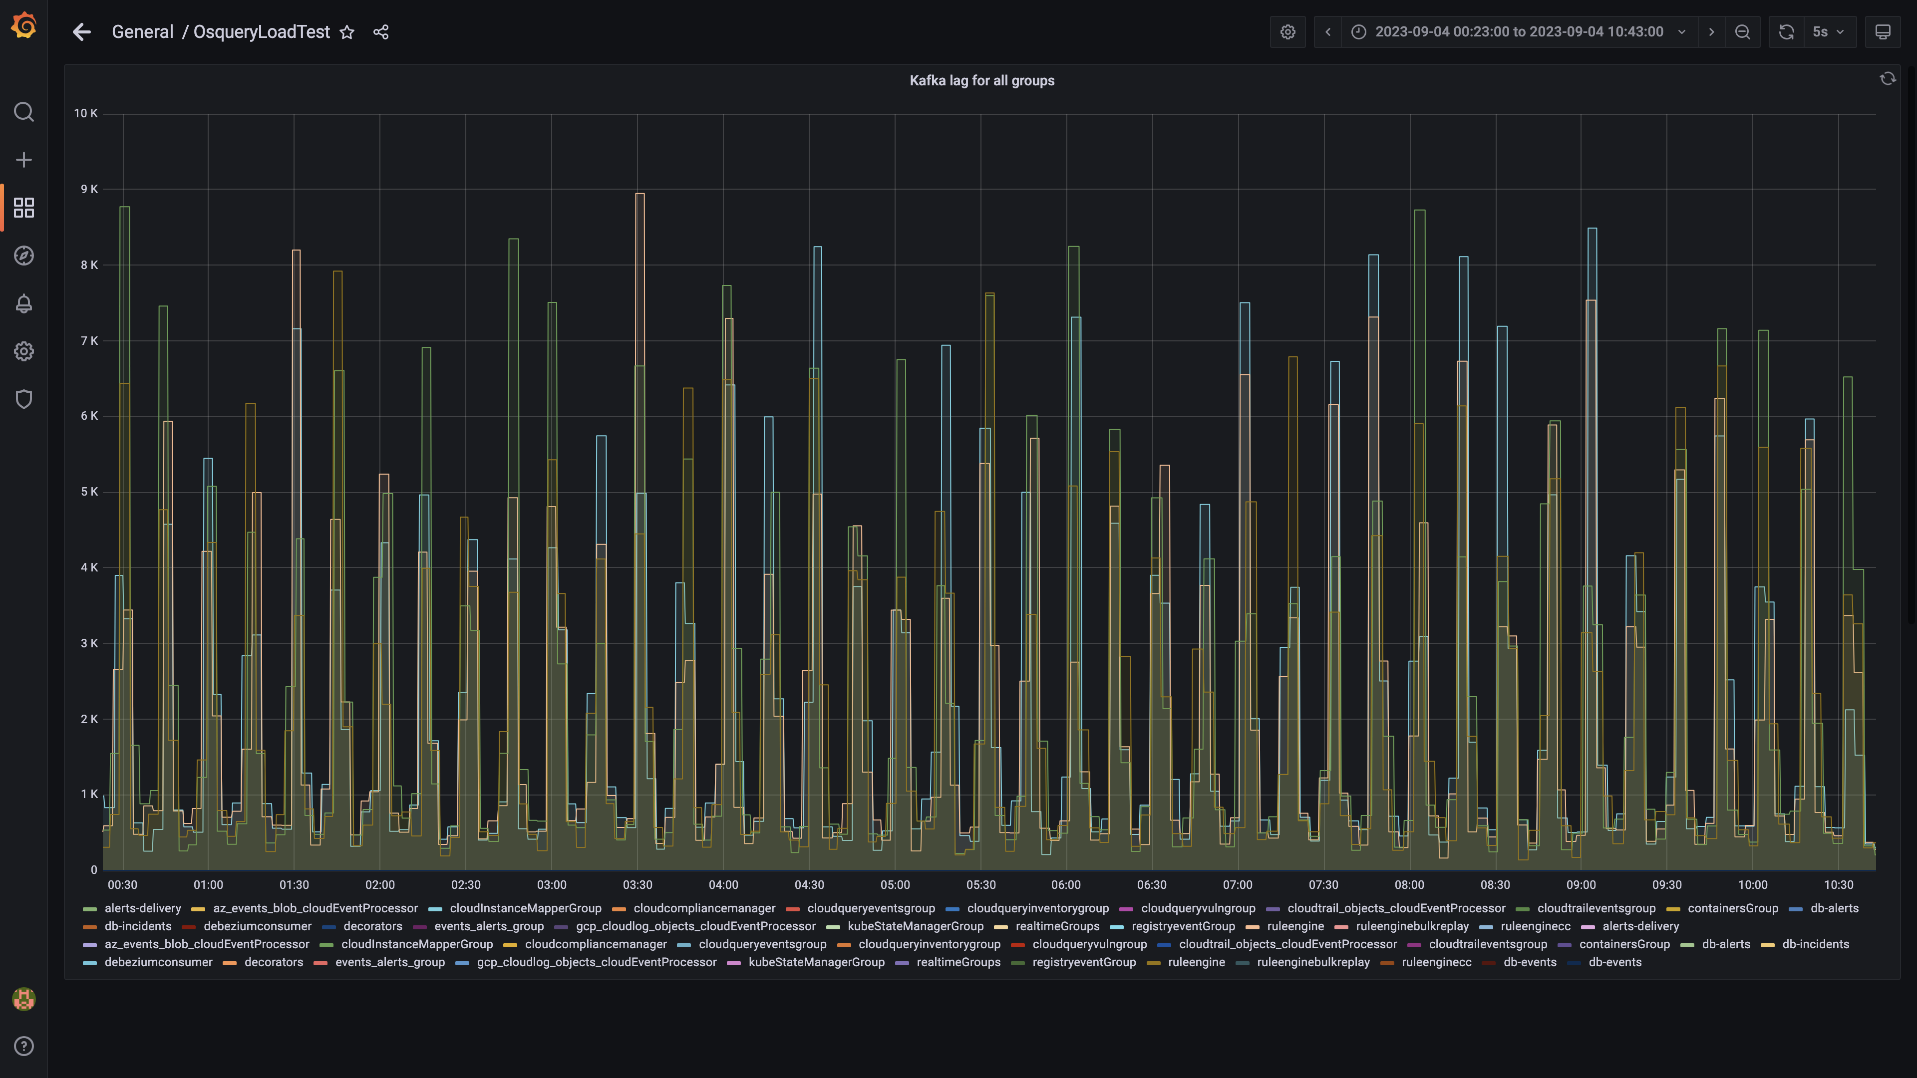

### Active client connections

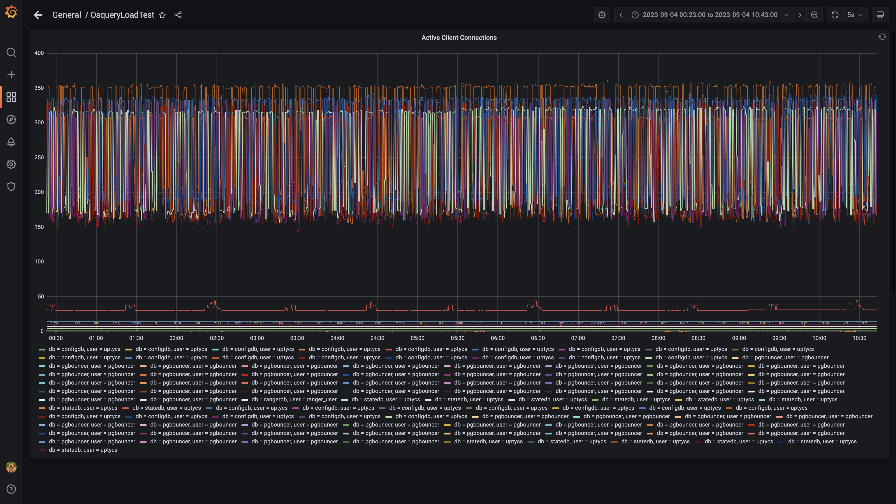

### Loading failed : panel 130 not loaded in given time

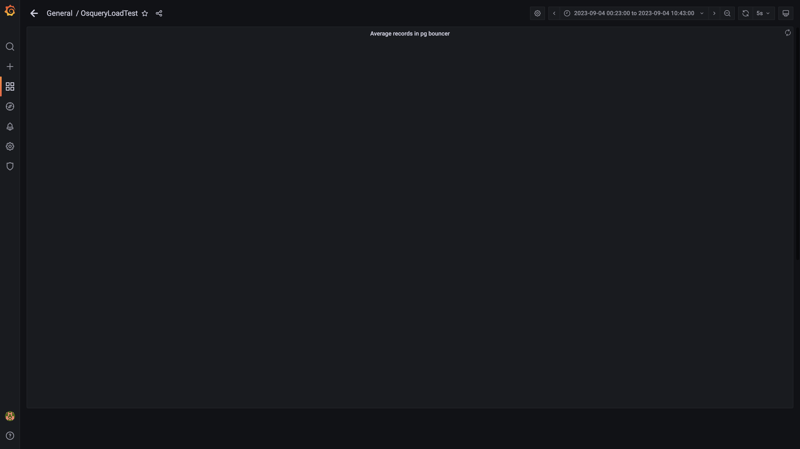

### Loading failed : panel 128 not loaded in given time

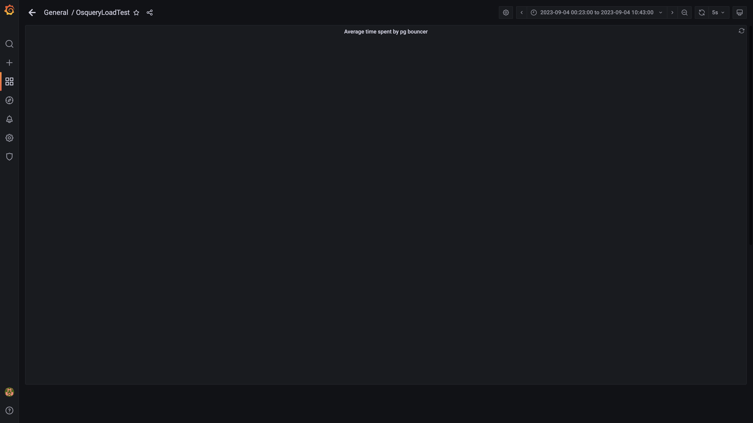

### Redis client connections for tls

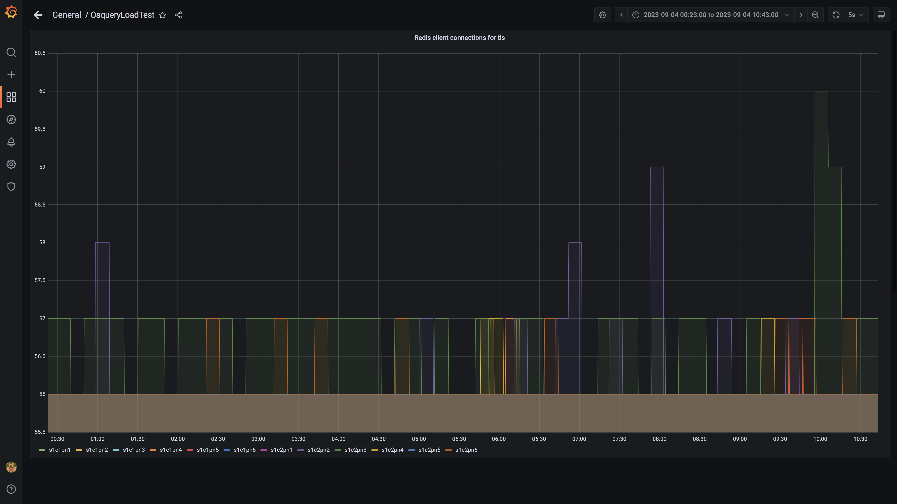

### Loading failed : panel 108 not loaded in given time

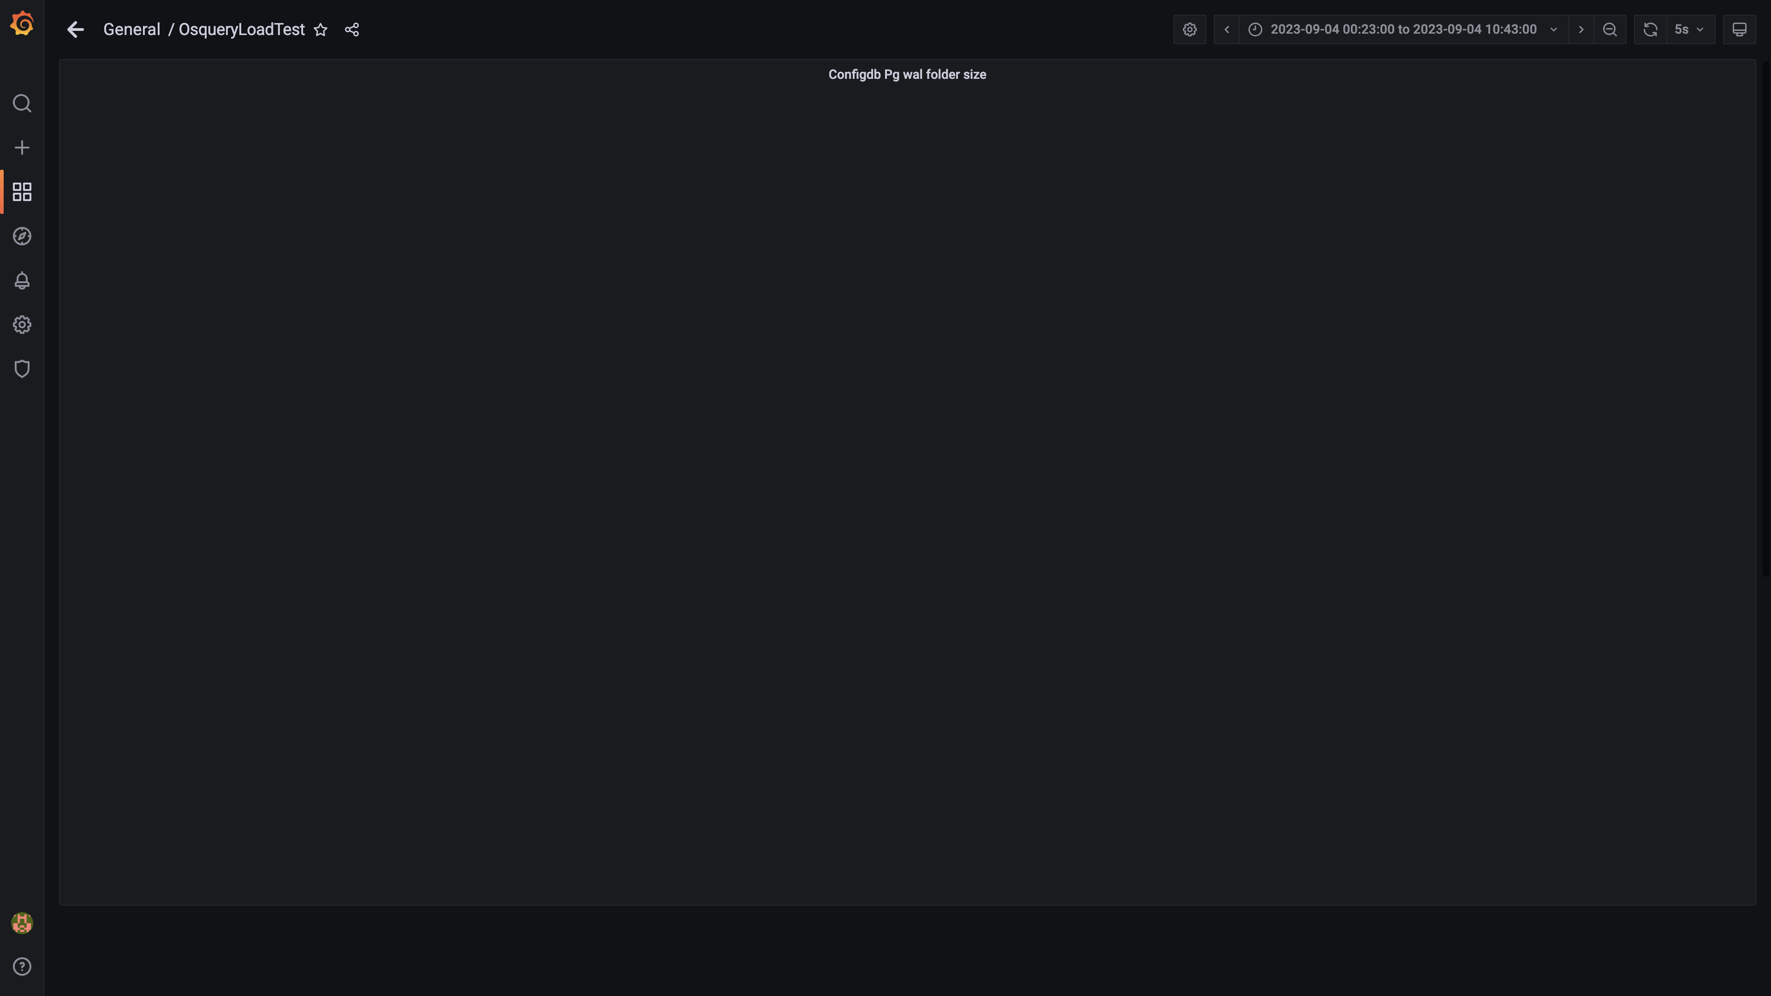

### Loading failed : panel 110 not loaded in given time

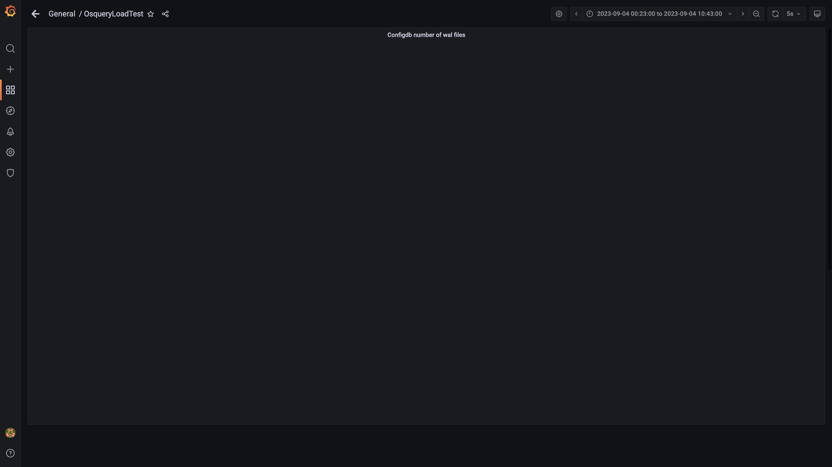

### Top 10 redis client connections by app

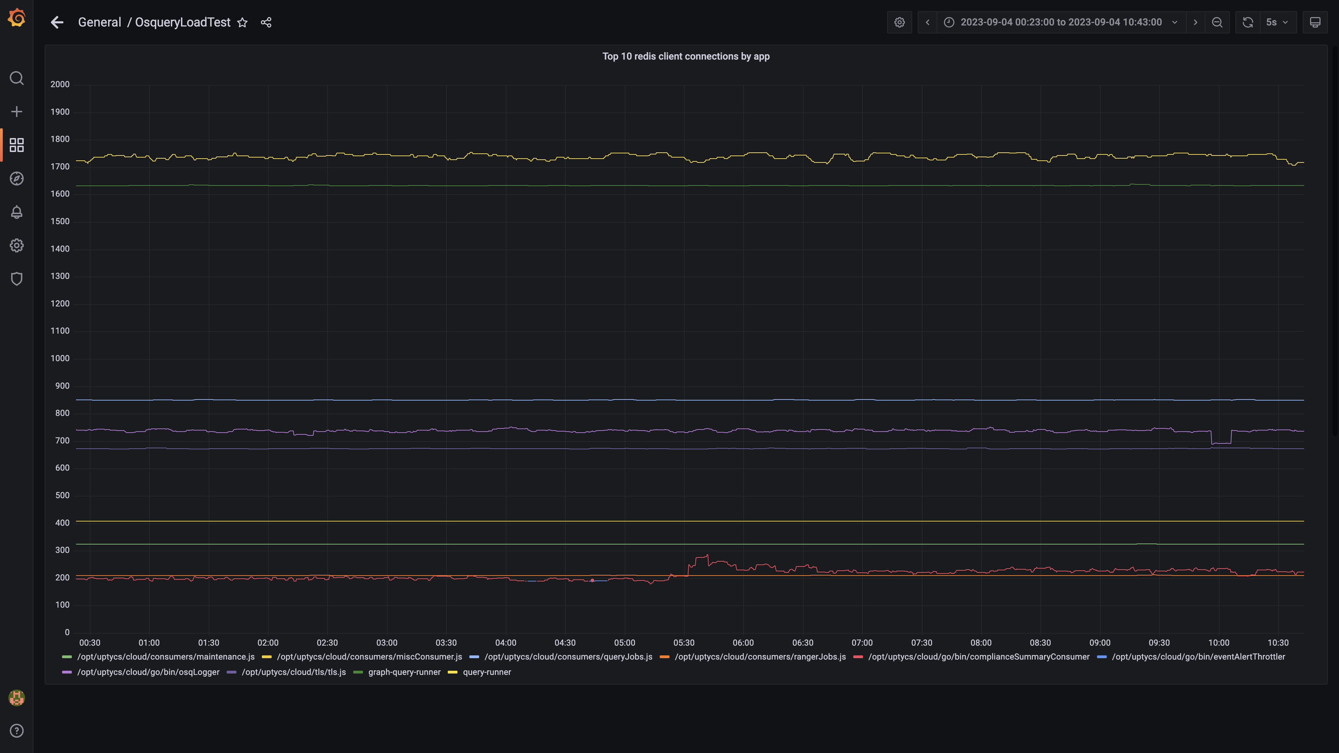

### Loading failed : panel 112 not loaded in given time

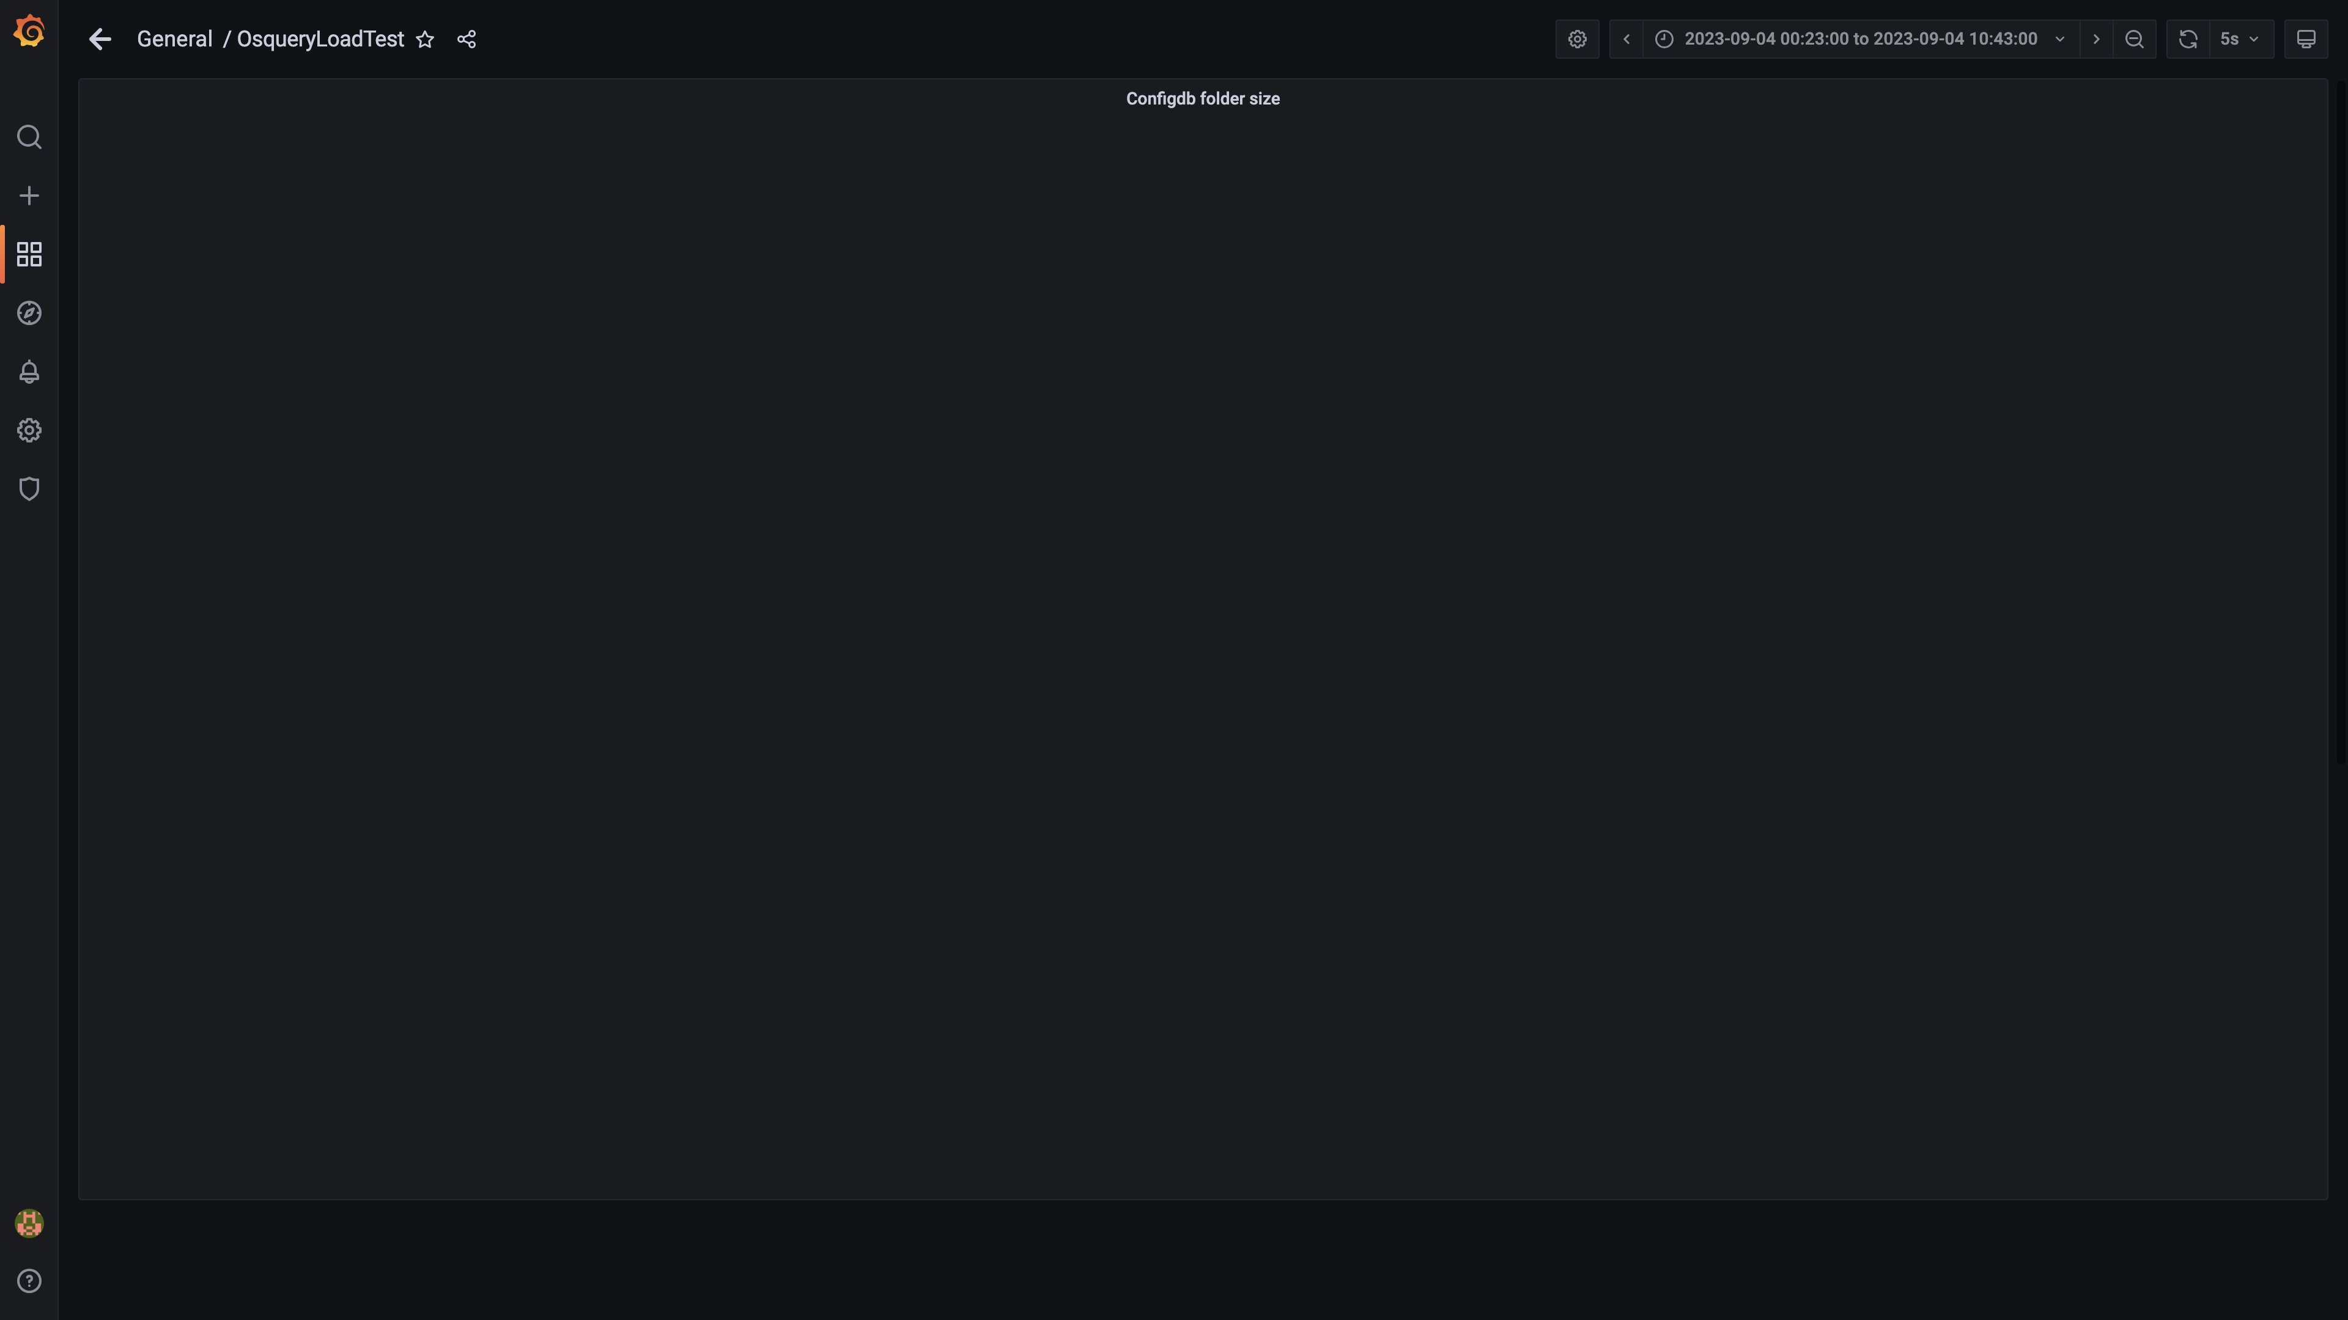

### Compaction status

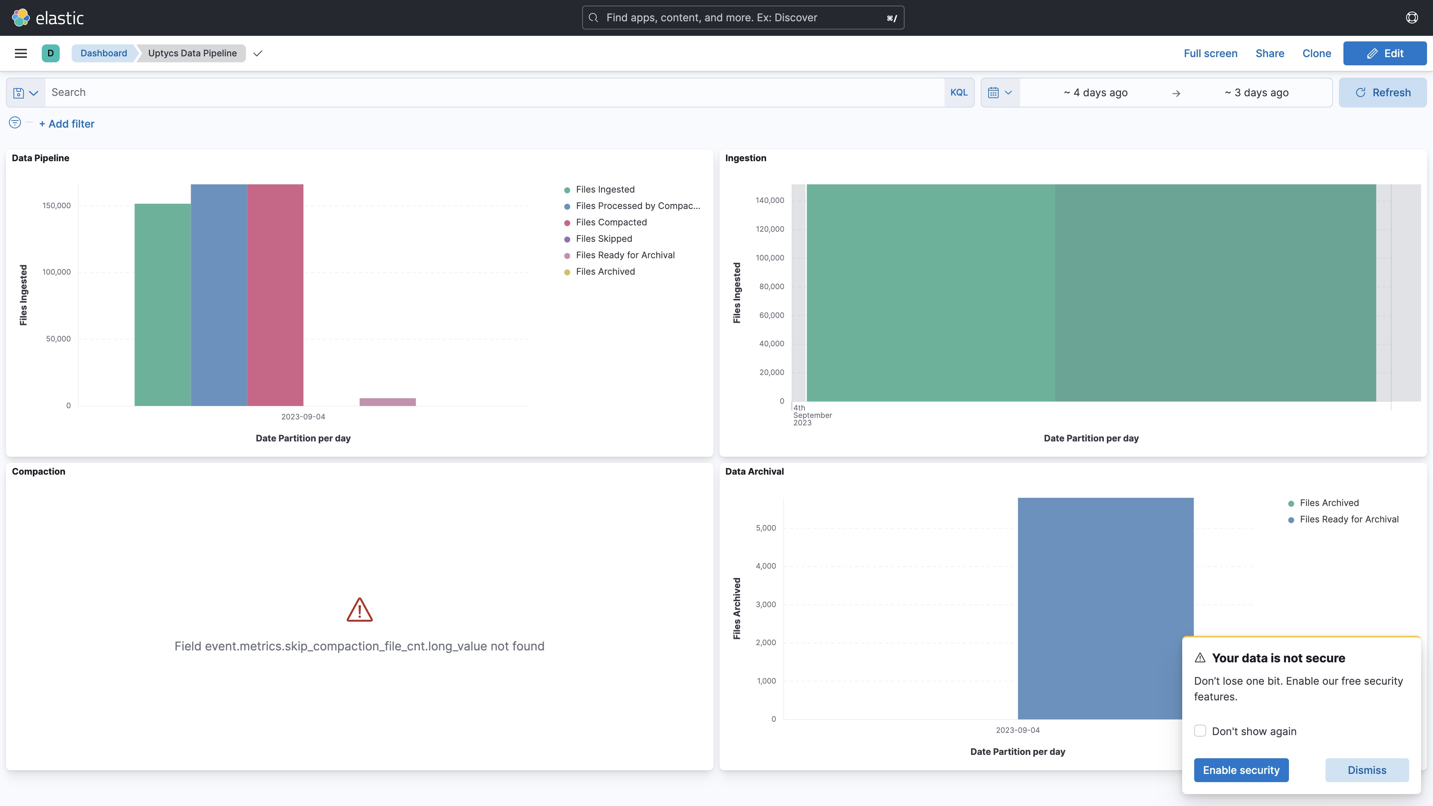

## Average Resource Utilization

### Comparision of Average Memory utilization

|  |  |  |  |  |
| --- | --- | --- | --- | --- |
| Metric | 137006 | 138005 | Absolute(%) | Relative(%) |
| Memory used by s1c1dn1 | 79.02% | 53.47% | 25.55% ⬇️ | 32.33% ⬇️ |
| Memory used by s1c1dn2 | 66.60% | 53.56% | 13.03% ⬇️ | 19.57% ⬇️ |
| Memory used by s1c1dn3 | 67.26% | 49.66% | 17.60% ⬇️ | 26.17% ⬇️ |
| Memory used by s1c1dn4 | 74.22% | 53.77% | 20.45% ⬇️ | 27.55% ⬇️ |
| Memory used by s1c1dn5 | 72.73% | 49.92% | 22.81% ⬇️ | 31.36% ⬇️ |
| Memory used by s1c1dn6 | 74.27% | 51.52% | 22.76% ⬇️ | 30.64% ⬇️ |
| Memory used by s1c1pn1 | 39.81% | 47.02% | 7.21% ⬆️ | 18.10% ⬆️ |
| Memory used by s1c1pn2 | 29.91% | 49.21% | 19.29% ⬆️ | 64.50% ⬆️ |
| Memory used by s1c1pn3 | 36.71% | 46.12% | 9.41% ⬆️ | 25.64% ⬆️ |
| Memory used by s1c1pn4 | 36.04% | 50.96% | 14.91% ⬆️ | 41.38% ⬆️ |
| Memory used by s1c1pn5 | 40.29% | 52.46% | 12.17% ⬆️ | 30.19% ⬆️ |
| Memory used by s1c1pn6 | 36.03% | 51.61% | 15.58% ⬆️ | 43.25% ⬆️ |
| Memory used by s1c2dn1 | 57.63% | 53.48% | 4.14% ⬇️ | 7.19% ⬇️ |
| Memory used by s1c2dn2 | 54.76% | 42.96% | 11.80% ⬇️ | 21.55% ⬇️ |
| Memory used by s1c2dn3 | 54.48% | 40.80% | 13.68% ⬇️ | 25.11% ⬇️ |
| Memory used by s1c2dn4 | 67.89% | 53.80% | 14.09% ⬇️ | 20.76% ⬇️ |
| Memory used by s1c2dn5 | 67.85% | 51.34% | 16.51% ⬇️ | 24.33% ⬇️ |
| Memory used by s1c2dn6 | 68.61% | 52.78% | 15.83% ⬇️ | 23.07% ⬇️ |
| Memory used by s1c2pn1 | 32.91% | 41.65% | 8.74% ⬆️ | 26.54% ⬆️ |
| Memory used by s1c2pn2 | 30.89% | 47.97% | 17.07% ⬆️ | 55.27% ⬆️ |
| Memory used by s1c2pn3 | 30.54% | 48.14% | 17.60% ⬆️ | 57.63% ⬆️ |
| Memory used by s1c2pn4 | 30.61% | 47.10% | 16.49% ⬆️ | 53.88% ⬆️ |
| Memory used by s1c2pn5 | 35.75% | 48.33% | 12.59% ⬆️ | 35.21% ⬆️ |
| Memory used by s1c2pn6 | 34.75% | 48.22% | 13.46% ⬆️ | 38.74% ⬆️ |
| Memory used by s1cloudquery | - | 3.81% | - | - |
| Memory used by s1configdb1 | 14.92% | 2.10% | 12.82% ⬇️ | 85.90% ⬇️ |
| Memory used by s1configdb2 | 1.21% | 13.74% | 12.53% ⬆️ | 1036.52% ⬆️ |
| Memory used by s1elasticsearch | - | 26.53% | - | - |
| Memory used by s1kibana | - | 4.39% | - | - |
| Memory used by s1logstash1 | - | 16.50% | - | - |
| Memory used by s1logstash2 | - | 16.51% | - | - |
| Memory used by s1mlnode1 | - | 12.90% | - | - |
| Memory used by s1mlnode2 | - | 6.43% | - | - |
| Memory used by s1monitor | 26.52% | 4.41% | 22.10% ⬇️ | 83.36% ⬇️ |
| Memory used by s1stsnode1 | - | 6.70% | - | - |
| Memory used by s1stsnode2 | - | 16.89% | - | - |
| Memory used by s1stsnode3 | - | 8.45% | - | - |
| Memory used by Rule Engine s1c1pn1 | 6.79% | 7.22% | 0.43% ⬆️ | 6.28% ⬆️ |
| Memory used by Rule Engine s1c1pn2 | 6.70% | 7.10% | 0.40% ⬆️ | 5.98% ⬆️ |
| Memory used by Rule Engine s1c1pn3 | 6.58% | 7.01% | 0.43% ⬆️ | 6.51% ⬆️ |
| Memory used by Rule Engine s1c1pn4 | 6.60% | 7.13% | 0.53% ⬆️ | 7.99% ⬆️ |
| Memory used by Rule Engine s1c1pn5 | 6.63% | 6.94% | 0.31% ⬆️ | 4.67% ⬆️ |
| Memory used by Rule Engine s1c1pn6 | 6.57% | 7.30% | 0.73% ⬆️ | 11.08% ⬆️ |
| Memory used by Rule Engine s1c2pn1 | 6.23% | 7.16% | 0.93% ⬆️ | 14.95% ⬆️ |
| Memory used by Rule Engine s1c2pn2 | 6.38% | 7.25% | 0.88% ⬆️ | 13.77% ⬆️ |
| Memory used by Rule Engine s1c2pn3 | 6.29% | 7.15% | 0.86% ⬆️ | 13.64% ⬆️ |
| Memory used by Rule Engine s1c2pn4 | 6.26% | 6.95% | 0.68% ⬆️ | 10.89% ⬆️ |
| Memory used by Rule Engine s1c2pn5 | 6.34% | 6.92% | 0.57% ⬆️ | 9.03% ⬆️ |
| Memory used by Rule Engine s1c2pn6 | 6.19% | 7.27% | 1.08% ⬆️ | 17.37% ⬆️ |
| Memory used by Osquery Ingestion s1c1dn1 | 8.60% | 6.74% | 1.86% ⬇️ | 21.64% ⬇️ |
| Memory used by Osquery Ingestion s1c1dn2 | 8.39% | 6.23% | 2.17% ⬇️ | 25.80% ⬇️ |
| Memory used by Osquery Ingestion s1c1dn3 | 8.28% | 6.76% | 1.52% ⬇️ | 18.40% ⬇️ |
| Memory used by Osquery Ingestion s1c1dn4 | 11.02% | 8.87% | 2.15% ⬇️ | 19.49% ⬇️ |
| Memory used by Osquery Ingestion s1c1dn5 | 10.98% | 8.73% | 2.25% ⬇️ | 20.50% ⬇️ |
| Memory used by Osquery Ingestion s1c1dn6 | 11.05% | 8.84% | 2.22% ⬇️ | 20.05% ⬇️ |
| Memory used by Osquery Ingestion s1c2dn1 | 8.28% | 6.18% | 2.10% ⬇️ | 25.33% ⬇️ |
| Memory used by Osquery Ingestion s1c2dn2 | 8.04% | 6.70% | 1.35% ⬇️ | 16.74% ⬇️ |
| Memory used by Osquery Ingestion s1c2dn3 | 8.11% | 6.78% | 1.34% ⬇️ | 16.48% ⬇️ |
| Memory used by Osquery Ingestion s1c2dn4 | 10.50% | 9.01% | 1.49% ⬇️ | 14.20% ⬇️ |
| Memory used by Osquery Ingestion s1c2dn5 | 10.65% | 8.82% | 1.84% ⬇️ | 17.23% ⬇️ |
| Memory used by Osquery Ingestion s1c2dn6 | 10.80% | 8.75% | 2.04% ⬇️ | 18.92% ⬇️ |
| Memory used by Kafka s1c1pn1 | 2.83% | 2.82% | 0.02% ⬇️ | 0.58% ⬇️ |
| Memory used by Kafka s1c1pn2 | 3.55% | 3.31% | 0.24% ⬇️ | 6.68% ⬇️ |
| Memory used by Kafka s1c1pn3 | 3.56% | 3.30% | 0.26% ⬇️ | 7.34% ⬇️ |
| Memory used by Kafka s1c1pn4 | 3.56% | 3.36% | 0.20% ⬇️ | 5.58% ⬇️ |
| Memory used by Kafka s1c1pn5 | 3.56% | 3.38% | 0.18% ⬇️ | 5.06% ⬇️ |
| Memory used by Kafka s1c1pn6 | 3.55% | 3.38% | 0.17% ⬇️ | 4.68% ⬇️ |
| Memory used by Kafka s1c2pn1 | 2.90% | 2.93% | 0.04% ⬆️ | 1.23% ⬆️ |
| Memory used by Kafka s1c2pn2 | 3.54% | 3.40% | 0.14% ⬇️ | 3.86% ⬇️ |
| Memory used by Kafka s1c2pn3 | 3.47% | 3.40% | 0.07% ⬇️ | 2.01% ⬇️ |
| Memory used by Kafka s1c2pn4 | 3.54% | 3.37% | 0.17% ⬇️ | 4.66% ⬇️ |
| Memory used by Kafka s1c2pn5 | 3.52% | 3.40% | 0.13% ⬇️ | 3.61% ⬇️ |
| Memory used by Kafka s1c2pn6 | 3.52% | 3.32% | 0.20% ⬇️ | 5.72% ⬇️ |
| Memory used by Trino s1c1dn1 | 23.35% | 11.08% | 12.27% ⬇️ | 52.56% ⬇️ |
| Memory used by Trino s1c1dn2 | 15.39% | 15.10% | 0.29% ⬇️ | 1.85% ⬇️ |
| Memory used by Trino s1c1dn3 | 15.48% | 14.50% | 0.98% ⬇️ | 6.32% ⬇️ |
| Memory used by Trino s1c1dn4 | 16.02% | 15.40% | 0.62% ⬇️ | 3.88% ⬇️ |
| Memory used by Trino s1c1dn5 | 15.89% | 15.20% | 0.69% ⬇️ | 4.34% ⬇️ |
| Memory used by Trino s1c1dn6 | 16.16% | 14.90% | 1.26% ⬇️ | 7.80% ⬇️ |
| Memory used by Trino s1c2dn1 | 15.12% | 24.35% | 9.23% ⬆️ | 61.09% ⬆️ |
| Memory used by Trino s1c2dn2 | 15.47% | 16.39% | 0.93% ⬆️ | 5.98% ⬆️ |
| Memory used by Trino s1c2dn3 | 15.28% | 16.29% | 1.02% ⬆️ | 6.66% ⬆️ |
| Memory used by Trino s1c2dn4 | 16.06% | 17.69% | 1.63% ⬆️ | 10.14% ⬆️ |
| Memory used by Trino s1c2dn5 | 16.23% | 17.38% | 1.15% ⬆️ | 7.08% ⬆️ |
| Memory used by Trino s1c2dn6 | 16.48% | 17.49% | 1.01% ⬆️ | 6.16% ⬆️ |
| Memory used by Tls s1c1pn1 | 0.26% | 0.74% | 0.48% ⬆️ | 180.29% ⬆️ |
| Memory used by Tls s1c1pn2 | 0.27% | 0.72% | 0.45% ⬆️ | 169.29% ⬆️ |
| Memory used by Tls s1c1pn3 | 0.27% | 0.77% | 0.51% ⬆️ | 189.51% ⬆️ |
| Memory used by Tls s1c1pn4 | 0.27% | 0.76% | 0.49% ⬆️ | 181.74% ⬆️ |
| Memory used by Tls s1c1pn5 | 0.27% | 0.79% | 0.53% ⬆️ | 199.10% ⬆️ |
| Memory used by Tls s1c1pn6 | 0.27% | 0.80% | 0.53% ⬆️ | 199.40% ⬆️ |
| Memory used by Tls s1c2pn1 | 0.27% | 0.77% | 0.50% ⬆️ | 184.25% ⬆️ |
| Memory used by Tls s1c2pn2 | 0.27% | 0.76% | 0.49% ⬆️ | 181.70% ⬆️ |
| Memory used by Tls s1c2pn3 | 0.27% | 0.79% | 0.52% ⬆️ | 193.73% ⬆️ |
| Memory used by Tls s1c2pn4 | 0.27% | 0.76% | 0.49% ⬆️ | 183.69% ⬆️ |
| Memory used by Tls s1c2pn5 | 0.27% | 0.84% | 0.57% ⬆️ | 212.83% ⬆️ |
| Memory used by Tls s1c2pn6 | 0.27% | 0.83% | 0.56% ⬆️ | 211.38% ⬆️ |
| Memory used by Logger s1c1pn4 | 1.20% | 0.47% | 0.73% ⬇️ | 60.54% ⬇️ |
| Memory used by Logger s1c1pn5 | 1.20% | 0.44% | 0.75% ⬇️ | 63.01% ⬇️ |
| Memory used by Logger s1c1pn6 | 1.29% | 0.46% | 0.83% ⬇️ | 63.99% ⬇️ |
| Memory used by Logger s1c2pn2 | 1.20% | 0.40% | 0.80% ⬇️ | 66.74% ⬇️ |
| Memory used by Logger s1c2pn3 | 1.20% | 0.46% | 0.74% ⬇️ | 61.73% ⬇️ |
| Memory used by Logger s1c2pn4 | 1.20% | 0.49% | 0.71% ⬇️ | 59.33% ⬇️ |
| Memory used by Logger s1c2pn5 | 1.20% | 0.34% | 0.86% ⬇️ | 71.56% ⬇️ |
| Memory used by Logger s1c2pn6 | 1.20% | 0.36% | 0.84% ⬇️ | 69.82% ⬇️ |

### Comparision of Average CPU utilization

|  |  |  |  |  |
| --- | --- | --- | --- | --- |
| Metric | 137006 | 138005 | Absolute(%) | Relative(%) |
| CPU used by s1c1dn1 | 71.24% | 15.18% | 56.06% ⬇️ | 78.69% ⬇️ |
| CPU used by s1c1dn2 | 72.72% | 15.15% | 57.57% ⬇️ | 79.17% ⬇️ |
| CPU used by s1c1dn3 | 70.17% | 13.46% | 56.70% ⬇️ | 80.81% ⬇️ |
| CPU used by s1c1dn4 | 68.56% | 13.29% | 55.26% ⬇️ | 80.61% ⬇️ |
| CPU used by s1c1dn5 | 68.10% | 14.50% | 53.60% ⬇️ | 78.70% ⬇️ |
| CPU used by s1c1dn6 | 69.58% | 15.19% | 54.39% ⬇️ | 78.16% ⬇️ |
| CPU used by s1c1pn1 | 84.66% | 39.69% | 44.97% ⬇️ | 53.11% ⬇️ |
| CPU used by s1c1pn2 | 58.89% | 48.40% | 10.49% ⬇️ | 17.81% ⬇️ |
| CPU used by s1c1pn3 | 75.95% | 45.97% | 29.98% ⬇️ | 39.48% ⬇️ |
| CPU used by s1c1pn4 | 71.98% | 62.17% | 9.82% ⬇️ | 13.64% ⬇️ |
| CPU used by s1c1pn5 | 77.46% | 62.01% | 15.45% ⬇️ | 19.95% ⬇️ |
| CPU used by s1c1pn6 | 78.94% | 61.69% | 17.25% ⬇️ | 21.86% ⬇️ |
| CPU used by s1c2dn1 | 64.19% | 15.49% | 48.70% ⬇️ | 75.87% ⬇️ |
| CPU used by s1c2dn2 | 61.54% | 12.84% | 48.70% ⬇️ | 79.13% ⬇️ |
| CPU used by s1c2dn3 | 60.80% | 12.97% | 47.83% ⬇️ | 78.66% ⬇️ |
| CPU used by s1c2dn4 | 61.16% | 12.78% | 48.38% ⬇️ | 79.10% ⬇️ |
| CPU used by s1c2dn5 | 60.90% | 16.40% | 44.50% ⬇️ | 73.07% ⬇️ |
| CPU used by s1c2dn6 | 61.74% | 12.71% | 49.03% ⬇️ | 79.42% ⬇️ |
| CPU used by s1c2pn1 | 65.99% | 46.50% | 19.49% ⬇️ | 29.53% ⬇️ |
| CPU used by s1c2pn2 | 59.55% | 61.06% | 1.51% ⬆️ | 2.54% ⬆️ |
| CPU used by s1c2pn3 | 57.05% | 63.15% | 6.10% ⬆️ | 10.69% ⬆️ |
| CPU used by s1c2pn4 | 63.51% | 62.30% | 1.21% ⬇️ | 1.91% ⬇️ |
| CPU used by s1c2pn5 | 68.50% | 61.89% | 6.61% ⬇️ | 9.65% ⬇️ |
| CPU used by s1c2pn6 | 77.75% | 63.53% | 14.23% ⬇️ | 18.30% ⬇️ |
| CPU used by s1cloudquery | - | 6.93% | - | - |
| CPU used by s1configdb1 | 36.75% | 1.84% | 34.91% ⬇️ | 95.00% ⬇️ |
| CPU used by s1configdb2 | 5.11% | 96.60% | 91.50% ⬆️ | 1792.14% ⬆️ |
| CPU used by s1elasticsearch | - | 4.90% | - | - |
| CPU used by s1kibana | - | 4.98% | - | - |
| CPU used by s1logstash1 | - | 13.57% | - | - |
| CPU used by s1logstash2 | - | 13.60% | - | - |
| CPU used by s1mlnode1 | - | 11.26% | - | - |
| CPU used by s1mlnode2 | - | 6.43% | - | - |
| CPU used by s1monitor | 4.47% | 1.87% | 2.60% ⬇️ | 58.12% ⬇️ |
| CPU used by s1stsnode1 | - | 2.84% | - | - |
| CPU used by s1stsnode2 | - | 3.18% | - | - |
| CPU used by s1stsnode3 | - | 2.89% | - | - |
| CPU used by Rule Engine s1c1pn1 | 87.83% | 25.57% | 62.27% ⬇️ | 70.89% ⬇️ |
| CPU used by Rule Engine s1c1pn2 | 82.52% | 24.03% | 58.49% ⬇️ | 70.88% ⬇️ |
| CPU used by Rule Engine s1c1pn3 | 95.36% | 19.20% | 76.16% ⬇️ | 79.87% ⬇️ |
| CPU used by Rule Engine s1c1pn4 | 87.74% | 14.77% | 72.97% ⬇️ | 83.17% ⬇️ |
| CPU used by Rule Engine s1c1pn5 | 89.66% | 16.77% | 72.90% ⬇️ | 81.30% ⬇️ |
| CPU used by Rule Engine s1c1pn6 | 89.10% | 16.50% | 72.60% ⬇️ | 81.48% ⬇️ |
| CPU used by Rule Engine s1c2pn1 | 80.28% | 18.29% | 61.98% ⬇️ | 77.21% ⬇️ |
| CPU used by Rule Engine s1c2pn2 | 78.29% | 18.76% | 59.53% ⬇️ | 76.04% ⬇️ |
| CPU used by Rule Engine s1c2pn3 | 74.29% | 16.78% | 57.51% ⬇️ | 77.42% ⬇️ |
| CPU used by Rule Engine s1c2pn4 | 82.57% | 18.26% | 64.31% ⬇️ | 77.89% ⬇️ |
| CPU used by Rule Engine s1c2pn5 | 76.68% | 16.13% | 60.55% ⬇️ | 78.97% ⬇️ |
| CPU used by Rule Engine s1c2pn6 | 81.70% | 16.55% | 65.15% ⬇️ | 79.74% ⬇️ |
| CPU used by Osquery Ingestion s1c1dn1 | 179.24% | 28.27% | 150.97% ⬇️ | 84.23% ⬇️ |
| CPU used by Osquery Ingestion s1c1dn2 | 278.46% | 20.55% | 257.91% ⬇️ | 92.62% ⬇️ |
| CPU used by Osquery Ingestion s1c1dn3 | 281.93% | 31.45% | 250.48% ⬇️ | 88.85% ⬇️ |
| CPU used by Osquery Ingestion s1c1dn4 | 286.39% | 35.38% | 251.00% ⬇️ | 87.65% ⬇️ |
| CPU used by Osquery Ingestion s1c1dn5 | 280.85% | 32.82% | 248.03% ⬇️ | 88.32% ⬇️ |
| CPU used by Osquery Ingestion s1c1dn6 | 295.16% | 31.51% | 263.64% ⬇️ | 89.32% ⬇️ |
| CPU used by Osquery Ingestion s1c2dn1 | 150.57% | 28.83% | 121.74% ⬇️ | 80.85% ⬇️ |
| CPU used by Osquery Ingestion s1c2dn2 | 264.53% | 30.82% | 233.72% ⬇️ | 88.35% ⬇️ |
| CPU used by Osquery Ingestion s1c2dn3 | 251.18% | 33.37% | 217.81% ⬇️ | 86.71% ⬇️ |
| CPU used by Osquery Ingestion s1c2dn4 | 244.36% | 28.63% | 215.73% ⬇️ | 88.28% ⬇️ |
| CPU used by Osquery Ingestion s1c2dn5 | 267.92% | 33.18% | 234.74% ⬇️ | 87.61% ⬇️ |
| CPU used by Osquery Ingestion s1c2dn6 | 265.52% | 31.24% | 234.27% ⬇️ | 88.23% ⬇️ |
| CPU used by Kafka s1c1pn1 | 214.94% | 44.30% | 170.64% ⬇️ | 79.39% ⬇️ |
| CPU used by Kafka s1c1pn2 | 262.71% | 89.48% | 173.23% ⬇️ | 65.94% ⬇️ |
| CPU used by Kafka s1c1pn3 | 265.82% | 43.41% | 222.40% ⬇️ | 83.67% ⬇️ |
| CPU used by Kafka s1c1pn4 | 264.92% | 52.15% | 212.77% ⬇️ | 80.32% ⬇️ |
| CPU used by Kafka s1c1pn5 | 331.41% | 52.22% | 279.19% ⬇️ | 84.24% ⬇️ |
| CPU used by Kafka s1c1pn6 | 476.71% | 44.48% | 432.23% ⬇️ | 90.67% ⬇️ |
| CPU used by Kafka s1c2pn1 | 166.32% | 46.40% | 119.92% ⬇️ | 72.10% ⬇️ |
| CPU used by Kafka s1c2pn2 | 192.55% | 44.38% | 148.17% ⬇️ | 76.95% ⬇️ |
| CPU used by Kafka s1c2pn3 | 193.12% | 42.03% | 151.09% ⬇️ | 78.24% ⬇️ |
| CPU used by Kafka s1c2pn4 | 243.96% | 44.64% | 199.32% ⬇️ | 81.70% ⬇️ |
| CPU used by Kafka s1c2pn5 | 297.66% | 48.89% | 248.77% ⬇️ | 83.58% ⬇️ |
| CPU used by Kafka s1c2pn6 | 483.14% | 85.97% | 397.17% ⬇️ | 82.21% ⬇️ |
| CPU used by Trino s1c1dn1 | 104.57% | 4.35% | 100.22% ⬇️ | 95.84% ⬇️ |
| CPU used by Trino s1c1dn2 | 118.36% | 4.67% | 113.69% ⬇️ | 96.05% ⬇️ |
| CPU used by Trino s1c1dn3 | 118.30% | 3.01% | 115.28% ⬇️ | 97.45% ⬇️ |
| CPU used by Trino s1c1dn4 | 121.08% | 3.12% | 117.97% ⬇️ | 97.43% ⬇️ |
| CPU used by Trino s1c1dn5 | 120.97% | 2.87% | 118.10% ⬇️ | 97.63% ⬇️ |
| CPU used by Trino s1c1dn6 | 126.78% | 3.50% | 123.28% ⬇️ | 97.24% ⬇️ |
| CPU used by Trino s1c2dn1 | 118.51% | 28.66% | 89.85% ⬇️ | 75.81% ⬇️ |
| CPU used by Trino s1c2dn2 | 126.69% | 19.46% | 107.23% ⬇️ | 84.64% ⬇️ |
| CPU used by Trino s1c2dn3 | 111.08% | 18.71% | 92.37% ⬇️ | 83.16% ⬇️ |
| CPU used by Trino s1c2dn4 | 125.97% | 19.90% | 106.07% ⬇️ | 84.20% ⬇️ |
| CPU used by Trino s1c2dn5 | 123.99% | 19.24% | 104.75% ⬇️ | 84.48% ⬇️ |
| CPU used by Trino s1c2dn6 | 130.71% | 19.50% | 111.20% ⬇️ | 85.08% ⬇️ |
| CPU used by Tls s1c1pn1 | 84.08% | 87.50% | 3.42% ⬆️ | 4.06% ⬆️ |
| CPU used by Tls s1c1pn2 | 80.60% | 91.99% | 11.39% ⬆️ | 14.13% ⬆️ |
| CPU used by Tls s1c1pn3 | 84.45% | 92.97% | 8.53% ⬆️ | 10.10% ⬆️ |
| CPU used by Tls s1c1pn4 | 84.03% | 91.83% | 7.80% ⬆️ | 9.28% ⬆️ |
| CPU used by Tls s1c1pn5 | 85.36% | 91.58% | 6.22% ⬆️ | 7.29% ⬆️ |
| CPU used by Tls s1c1pn6 | 85.25% | 91.70% | 6.45% ⬆️ | 7.57% ⬆️ |
| CPU used by Tls s1c2pn1 | 78.88% | 89.80% | 10.92% ⬆️ | 13.84% ⬆️ |
| CPU used by Tls s1c2pn2 | 75.77% | 91.09% | 15.32% ⬆️ | 20.21% ⬆️ |
| CPU used by Tls s1c2pn3 | 76.35% | 101.98% | 25.62% ⬆️ | 33.56% ⬆️ |
| CPU used by Tls s1c2pn4 | 80.82% | 95.66% | 14.84% ⬆️ | 18.36% ⬆️ |
| CPU used by Tls s1c2pn5 | 81.82% | 93.78% | 11.97% ⬆️ | 14.62% ⬆️ |
| CPU used by Tls s1c2pn6 | 86.77% | 97.00% | 10.23% ⬆️ | 11.79% ⬆️ |
| CPU used by Logger s1c1pn1 | 304.53% | 4.32% | 300.20% ⬇️ | 98.58% ⬇️ |
| CPU used by Logger s1c1pn2 | 343.14% | 6.23% | 336.91% ⬇️ | 98.18% ⬇️ |
| CPU used by Logger s1c1pn3 | 315.74% | 6.22% | 309.52% ⬇️ | 98.03% ⬇️ |
| CPU used by Logger s1c1pn4 | 336.69% | 8.99% | 327.71% ⬇️ | 97.33% ⬇️ |
| CPU used by Logger s1c1pn5 | 319.23% | 8.26% | 310.97% ⬇️ | 97.41% ⬇️ |
| CPU used by Logger s1c1pn6 | 337.04% | 8.56% | 328.48% ⬇️ | 97.46% ⬇️ |
| CPU used by Logger s1c2pn1 | 258.25% | 7.00% | 251.26% ⬇️ | 97.29% ⬇️ |
| CPU used by Logger s1c2pn2 | 249.69% | 7.56% | 242.13% ⬇️ | 96.97% ⬇️ |
| CPU used by Logger s1c2pn3 | 244.80% | 8.26% | 236.54% ⬇️ | 96.62% ⬇️ |
| CPU used by Logger s1c2pn4 | 273.19% | 8.84% | 264.36% ⬇️ | 96.76% ⬇️ |
| CPU used by Logger s1c2pn5 | 308.82% | 6.20% | 302.62% ⬇️ | 97.99% ⬇️ |
| CPU used by Logger s1c2pn6 | 300.48% | 6.53% | 293.95% ⬇️ | 97.83% ⬇️ |

## Overall Usages

### Comparision of Overall Memory utilization

|  |  |  |  |
| --- | --- | --- | --- |
| Metric | 137006 | 138005 | Delta |
| Average Memory used by pnodes | 778.79 GB | 1088.10 GB | 39.72% (309.31 GB) ⬆️ |
| Average Memory used by dnodes | 1753.25 GB | 1326.48 GB | 24.34% (426.77 GB) ⬇️ |
| Average Memory used by pgnodes | 30.32 GB | 29.78 GB | 1.77% (0.54 GB) ⬇️ |

### Comparision of Overall CPU utilization

|  |  |  |  |
| --- | --- | --- | --- |
| Metric | 137006 | 138005 | Delta |
| Average CPU used by pnodes | 268.88 cores | 217.07 cores | 19.27% (51.81 cores) ⬇️ |
| Average CPU used by dnodes | 253.02 cores | 54.39 cores | 78.50% (198.63 cores) ⬇️ |
| Average CPU used by pgnodes | 13.39 cores | 31.50 cores | 135.19% (18.11 cores) ⬆️ |